JOB DESCRIPTION

JOB TITLE: Roaming Shop Assistant
DEPARTMENT: Retail
RESPONSIBLE TO: Retail Business Manager
PRINCIPAL PURPOSE OF JOB
You will be responsible for assistance in the management of the charity shop which will include the management of volunteers, stock management, merchandising, health & safety and financial procedures in the Managers absence.
This is a roaming role, covering our entire portfolio of shops across various geographical locations, providing additional support as required.
As a supportive team player, you will work cohesively with hospice staff and volunteers to positively promote the charity at any available opportunity, while upholding the organisational values.

ORGANISATION CHART

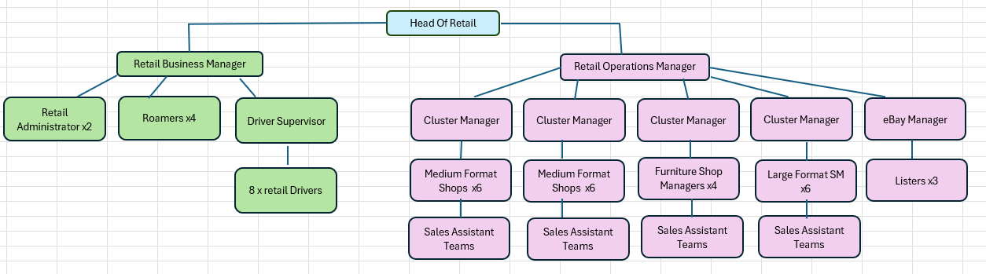

SPECIFIC DUTIES AND RESPONSIBILITIES
- Management and delegation of work to volunteers in the absence of the Shop Manager, providing adequate supervision to ensure satisfactory performance.
- Compliance with retail and organisational policy and procedures, including HR and employment legislation, trading standard regulations and raising awareness and understanding of security procedures with all our people (staff, volunteers and visitors).
- Ensure, so far as is reasonably practical, the health, safety and well being of staff, volunteers and others who may be affected by shop activities.
- Act as a key holder to the shop unit within procedural guidelines with effective training.
- Develop and maintain an in-depth knowledge of St Luke’s Hospice, its aims and objectives, service, culture and funding requirements.
- Strengthen and promote the St Luke’s Hospice brand through actively supporting and promoting all organisation initiatives/campaigns.
- Monitor building structure and appliances and alert retail administration office of any potential problems/non-compliance, in the absence of the Shop Manager.
- Assist in the testing of fire alarms, emergency lighting and carrying out regular fire practices in the shop, taking responsibility in the absence of the Shop Manager.
- Support our ecommerce department by forwarding high value donations which enable higher sales value where appropriate.
- Assist in the control of stock density and rotation, including the receipt, sorting, steaming, preparing and pricing of donated items for sale to ensure the highest possible flow of goods to shop floor, display and resale value of donated stock.
- Carry out scheduled stock takes, counting all purchased stock and submitting accurate counts.
- Ensure all relevant administration is completed within the agreed timescales, including cash handling, daily banking and security procedures.
- Embrace the change and development of new technology in the shop, encouraging volunteers to attend up skilling sessions, where available.
- Attend training courses as required, keeping abreast of industry standards, linked action plans & objectives.
- Work across the Retail Department and wider organisation as appropriate, providing support in shops as required and promoting the one team ethos where you work together with colleagues to provide exceptional service.
COMMUNICATION AND RELATIONSHIPS
- Ensure high levels of customer service are maintained, through quality of service and dealing with enquiries and complaints effectively and efficiently and leading by example to colleagues.
- Open communication with all of our people (staff, volunteers and visitors), building relationships and delivering excellent service to all.
- Flexibility is key in your approach to supporting colleagues across retail and the organisation.
- Work closely with the Retail Department to ensure customer and shop needs are met on time
KNOWLEDGE, TRAINING AND EXPERIENCE
- Experience of working for a charity
- Experience of working in a retail environment
- Provision of excellent customer service
- Cash handling
- Use of EPOS systems
- Educated to GCSE or equivalent in Maths and English (A-C)
- Computer literate.
PHYSICAL SKILLS
- Physical strength is required for manual lifting, sorting and movement of stock daily.

- VALUES

- Compassion - being present for others, without judgement, giving time to listen and care when needed.

- Respect - for others, both inside and outside of St Luke’s, is fundamental in truly embracing diversity, respecting the breadth of cultures, values and traditions and understanding the negative impact this can have when respect is missing.

- Integrity – Being honest, transparent and reliable.

- Professionalism - striving for excellence in everything you do. This may be set through high standards and challenging ourselves to do better.

- BEHAVIOURS

- Working together - truly part of St Luke’s, striving for team goals to provide the best service and encouraging confidence in colleagues.

- Taking responsibility – where you are self-motivated and consider what needs doing and when to work with others to do it. Able to work under pressure whilst being responsible for your own thoughts and behaviours.

- Being authentic – Being true to yourself, characterised by transparency and trust. You must be positive and realistic about your abilities, ‘doing as we say’ with good verbal communication.

- Embracing change - as an organisation we need to be adapting to our environment and seeking to continuously improve, which will mean embracing change.

Author
Version no
Reason for change
Date

